Vehicle vault

Data Dictionary
Users (unified for buyers & sellers — role-based)
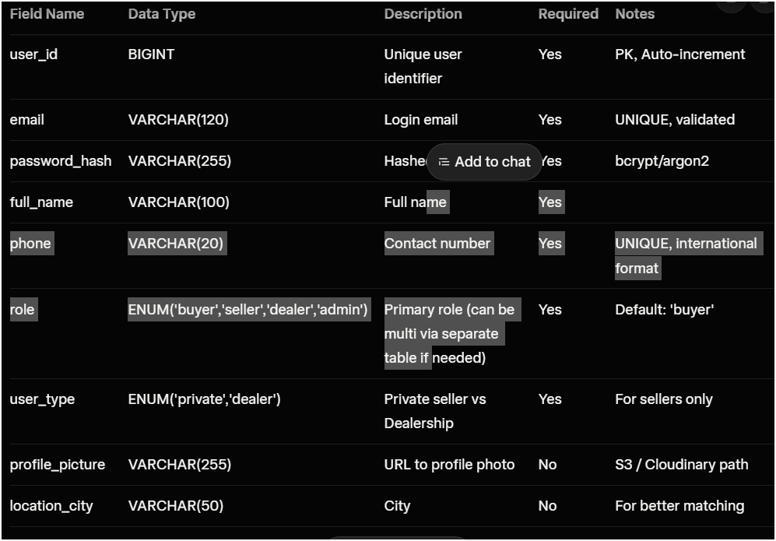
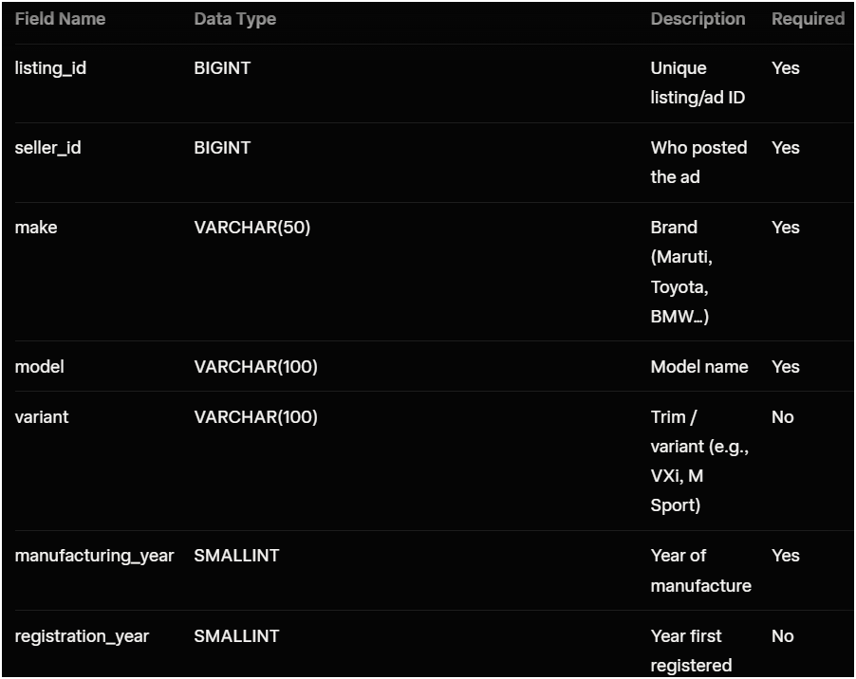
Vehiles / Car Listings (core entity — every ad is tied to one)
VehicleMedia (photos, 360° views, videos)
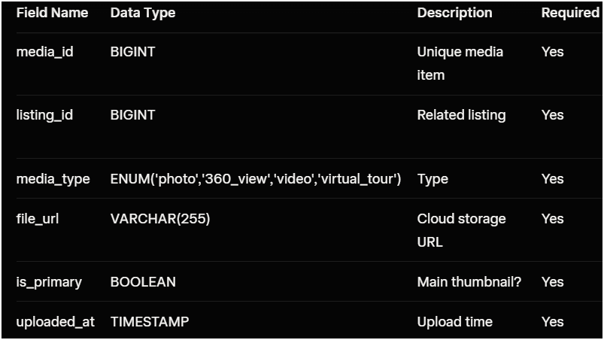
VehicleInspections / Reports (AI + third-party condition reports)
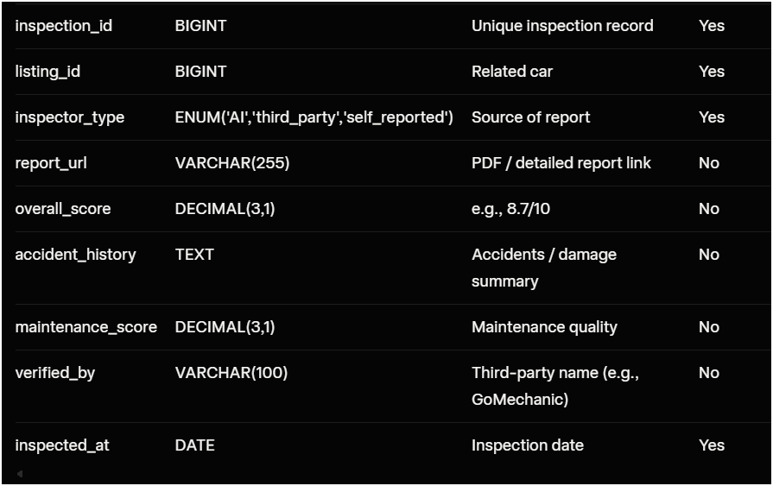

2. Workflow / Flowchart (Main End-to-End Process)

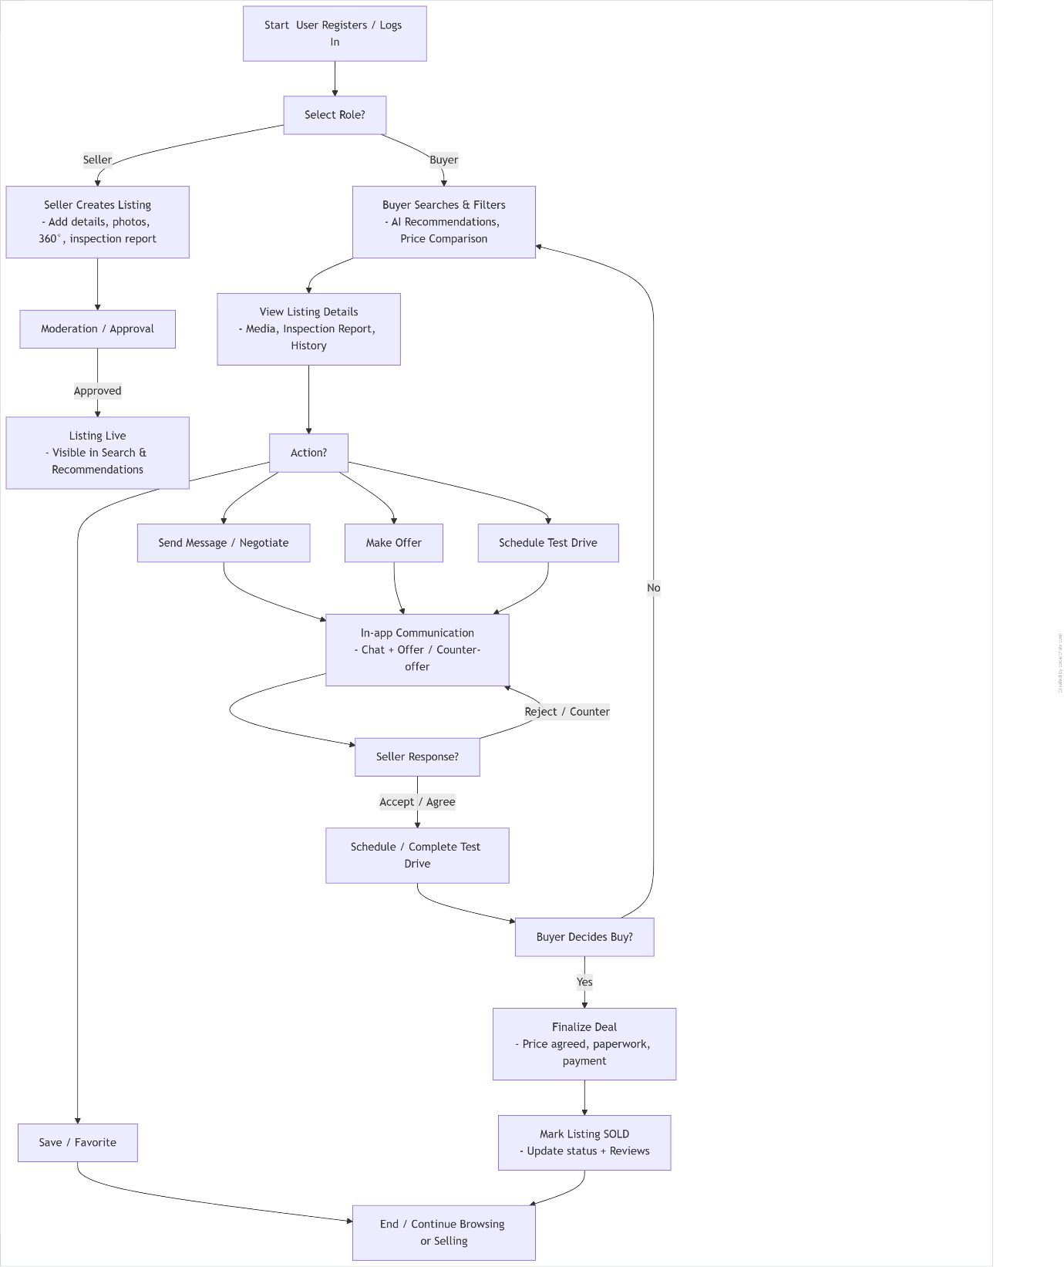

Vehicle vault

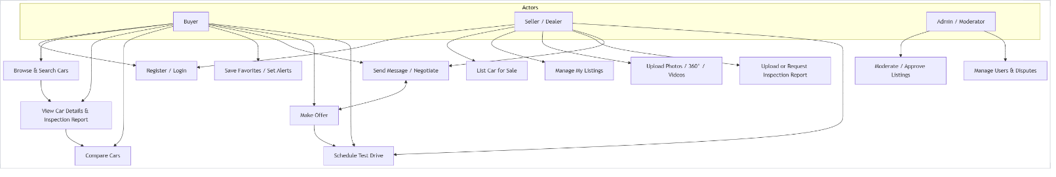
USE CASE DIAGRAM

CLASS DIAGRAM
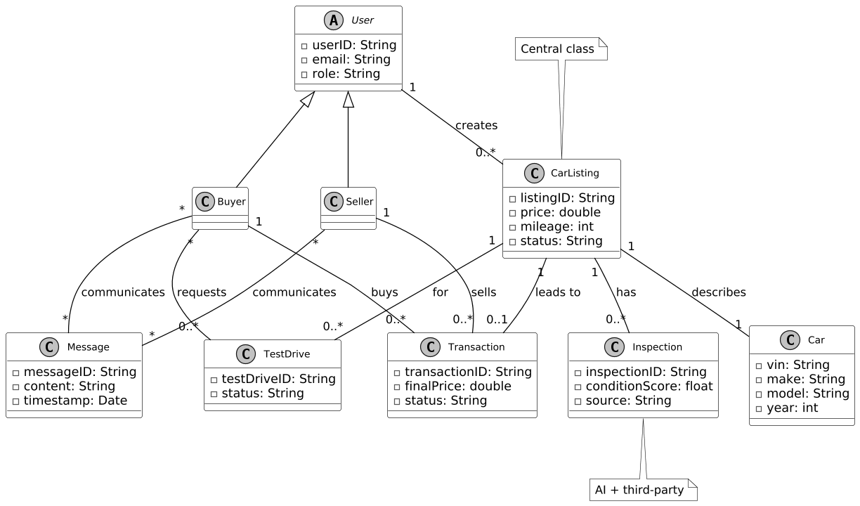

Activity Diagram – Buyer Purchase Flow (Search → Buy)

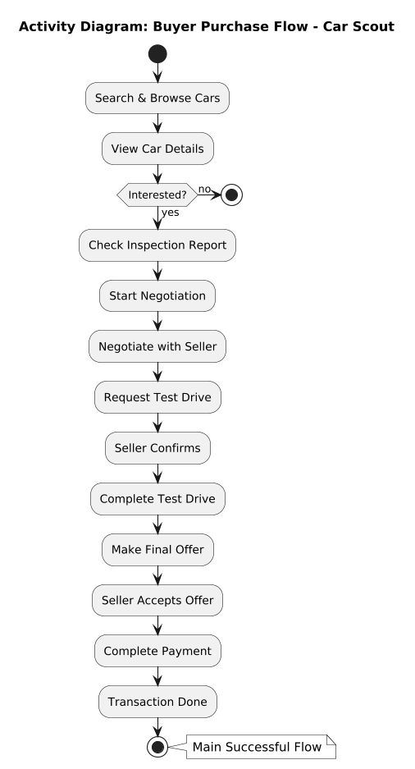

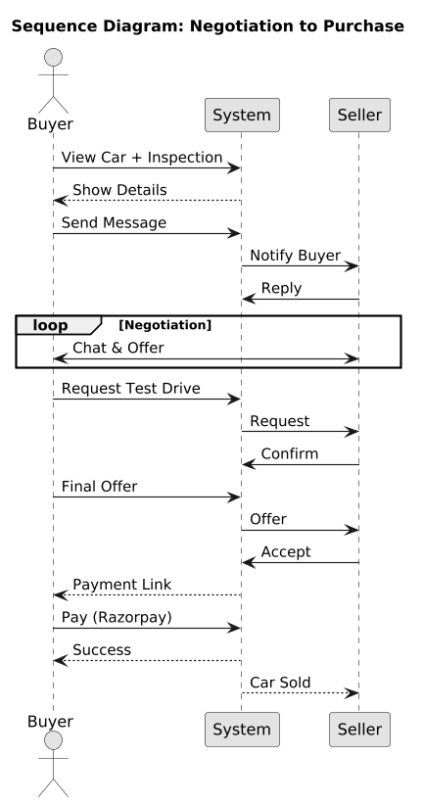

Project Overview
Category of the Projects
Software Application Projects (user-facing web app) + Research-Oriented Projects (light AI for recommendations) + Prototype/Hardware-Based Projects (software prototype).
Project Classification
- Software Development Projects (web app with database) + B. Artificial Intelligence & Data Science (basic AI recommendations).
Sub Classification
Web Applications (Django platform) + Machine Learning Models (simple AI for dealer recommendations) + Predictive Analytics (basic matching for buyers/sellers).
Title of Project
Car Scout: A Web Platform for Buying and Selling Vehicles with AI Recommendations.
Broad Area of Project
Software Development and E-Commerce (digital marketplace with light AI enhancements).
Deep Area of Project
Full-Stack Web Application with Basic AI-Driven Recommendations (focus on user interactions, negotiations, and simple AI to suggest best dealers for buyers or matches for sellers using Django/Python).
Any Grant Received
NO
Description of Project in Short
Car Scout is a Django-based web platform simplifying car buying/selling in India. Buyers search/filter vehicles, view details/history, negotiate via chat, schedule test drives, and get basic AI recommendations for best dealers based on preferences (e.g., location, ratings). Sellers list cars with photos/specs, manage inquiries, track sales, and receive similar AI suggestions for potential buyers. It promotes transparency and efficiency with secure transactions (Razorpay/UPI).

Platform Used
- Frontend/Backend: Django (Python framework for full-stack, handling views/templates/APIs).
- Database: PostgreSQL (structured data for listings/inspections).
- AI Component: Basic Python ML libraries (e.g., scikit-learn for simple recommendation models based on user data/ratings).
- Other Tools: AWS S3 (photo storage), Google Maps (location filters), Razorpay (payments), VAHAN API (VIN validation).

